9 -11 класс

Task 1. While studying any foreign language you can’t but learn a lot of information about the country this language is spoken, about its people, its customs and traditions. So, your first task is to say is these statements about England true or false.
- French was the official language of England for about 300 years.
- England takes its name from the Germanic tribe
- The River Thames which flows through London has over 500 bridges and 50 tunnels.
- The first public theater built in England was called The Globe.
- About 80,000 umbrellas are lost annually on the London Underground.
- There are over 30,000 John Smiths in Britain.
- The Warwick Castle is the oldest royal residence in the world and it is still being used by the royal family.
- The Queen is the only person in Britain with two birthdays. Her real birthday is on April 21st, and her “official” birthday is on the second Saturday in June.
- Before 19th century in Ireland and Britain Halloween lanterns were made from turnip, beet-root and rutabaga.

Task 2. Every country is proud of its sights. Your second task is to look at the pictures and write down the name of the place at every picture and what this place is famous for (1-2 sentences) Mind the correct spelling.

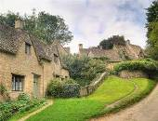 | 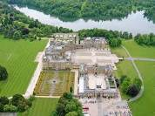 | 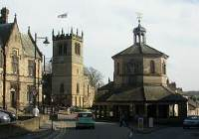 | 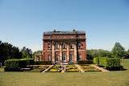
1 | 2 | 3 | 4
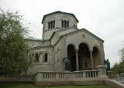
5 | 6 | 7 | 8

Task 3. Speaking about Great Britain we can’t but mention its literature. Your third task is to read the extract from the story of the famous British writer, to guess the name of the story, the name of the author.
At last the General, who was one of the least patient of military commanders, arose from his place in a violent access of passion, and indicated to his secretary that he had no further need for his services, with one of those explanatory gestures which are most rarely employed between gentlemen. The door being unfortunately open, Mr. Hartley fell downstairs head foremost.
He arose somewhat hurt and very deeply aggrieved. The life in the General's house precisely suited him; he moved, on a more or less doubtful footing, in very genteel company, he did little, he ate of the best, and he had a lukewarm satisfaction in the presence of Lady Vandeleur, which, in his own heart, he dubbed by a more emphatic name.
Immediately after he had been outraged by the military foot, he hurried to the boudoir and recounted his sorrows.
Task 4. Выполняя конкурсные задани , вы успели узнать много интересных фактов о Великобритании, познакомились с ее достопримечательностями и литературой. Пришло время для творческого задания. Вашим последним заданием будет написать синквейн на тему «Great Britain».
Алгоритм составления синквейна:
• На первой строчке – написать выбранное существительное.
• На второй строке - придумать к этому существительному два прилагательных, описывающие основную мысль.
• На третьей – придумать три глагола, описывающие действия в рамках темы.
• На четвертой – придумать фразу из нескольких слов, показывающую отношение к теме.
На пятой строке – сделать обобщающий вывод.

Пример синквейна на тему «Great Britain».

Great Britain
Wonderful, beautiful
Intrigue
I love you
You are great!

